Source ID - 76221099

Source Title - Acta Medica Philippina

Agreement URL - <https://actamedicaphilippina.upm.edu.ph/index.php/acta/issue/archive>

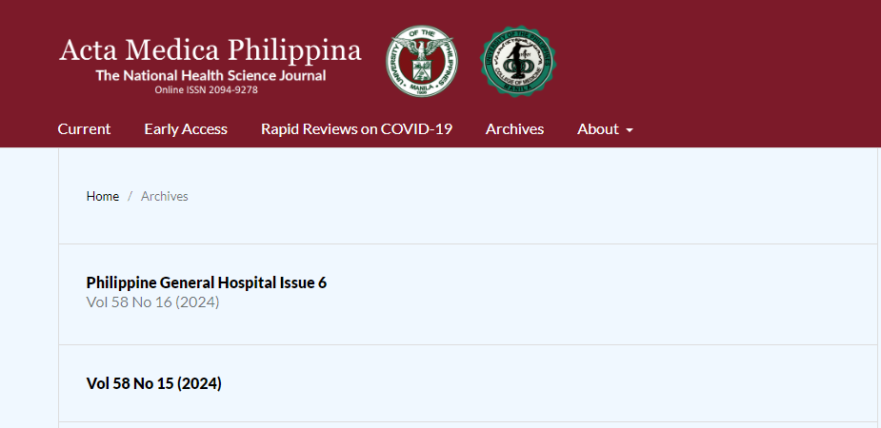

Click current to browse current issue

Issue

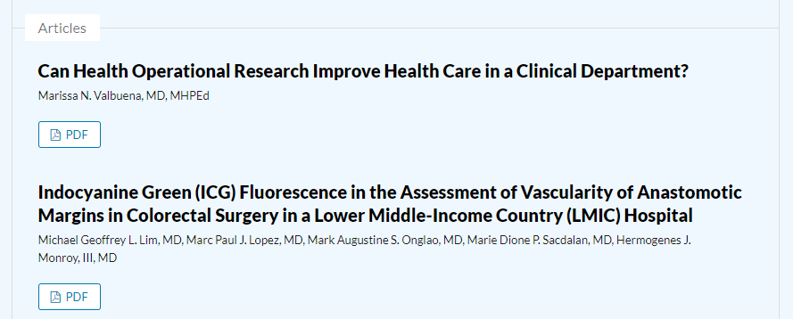

Volume

year

Click article to capture meta data

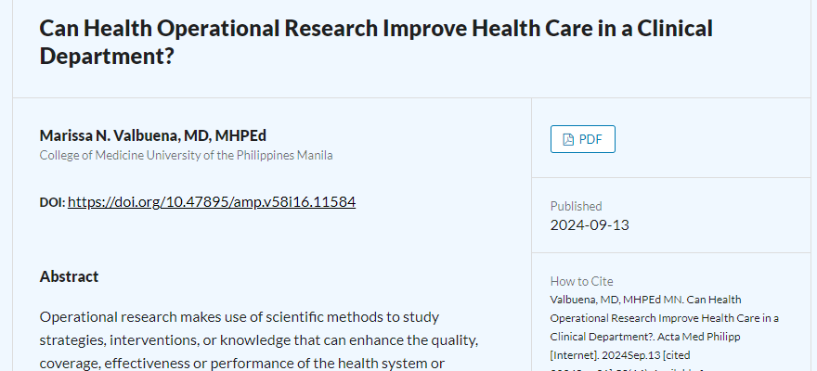

Click to download PDF

DOI number

Article title